**Lab 2:**[**Configuring interconnecting two PCs via an Ethernet switch**](https://docs.gns3.com/1wr2j2jEfX6ihyzpXzC23wQ8ymHzID4K3Hn99-qqshfg/index.html)

1. Extend the 3-node topology to 4 node configuration (3 PC's and 1 Ethernet switch)

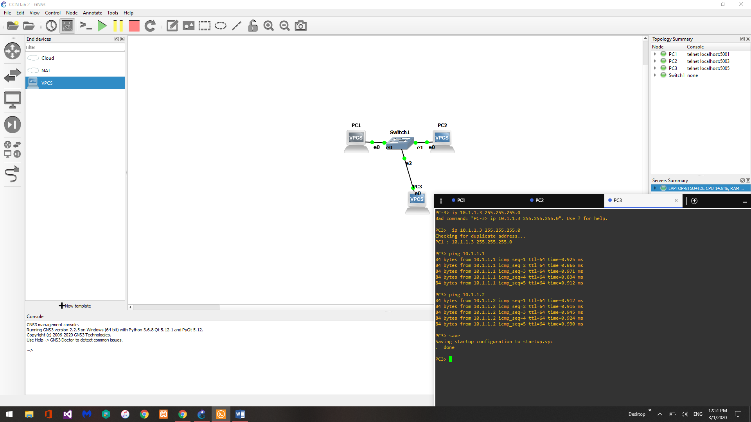

1. Measure the delay between pairs of PC's

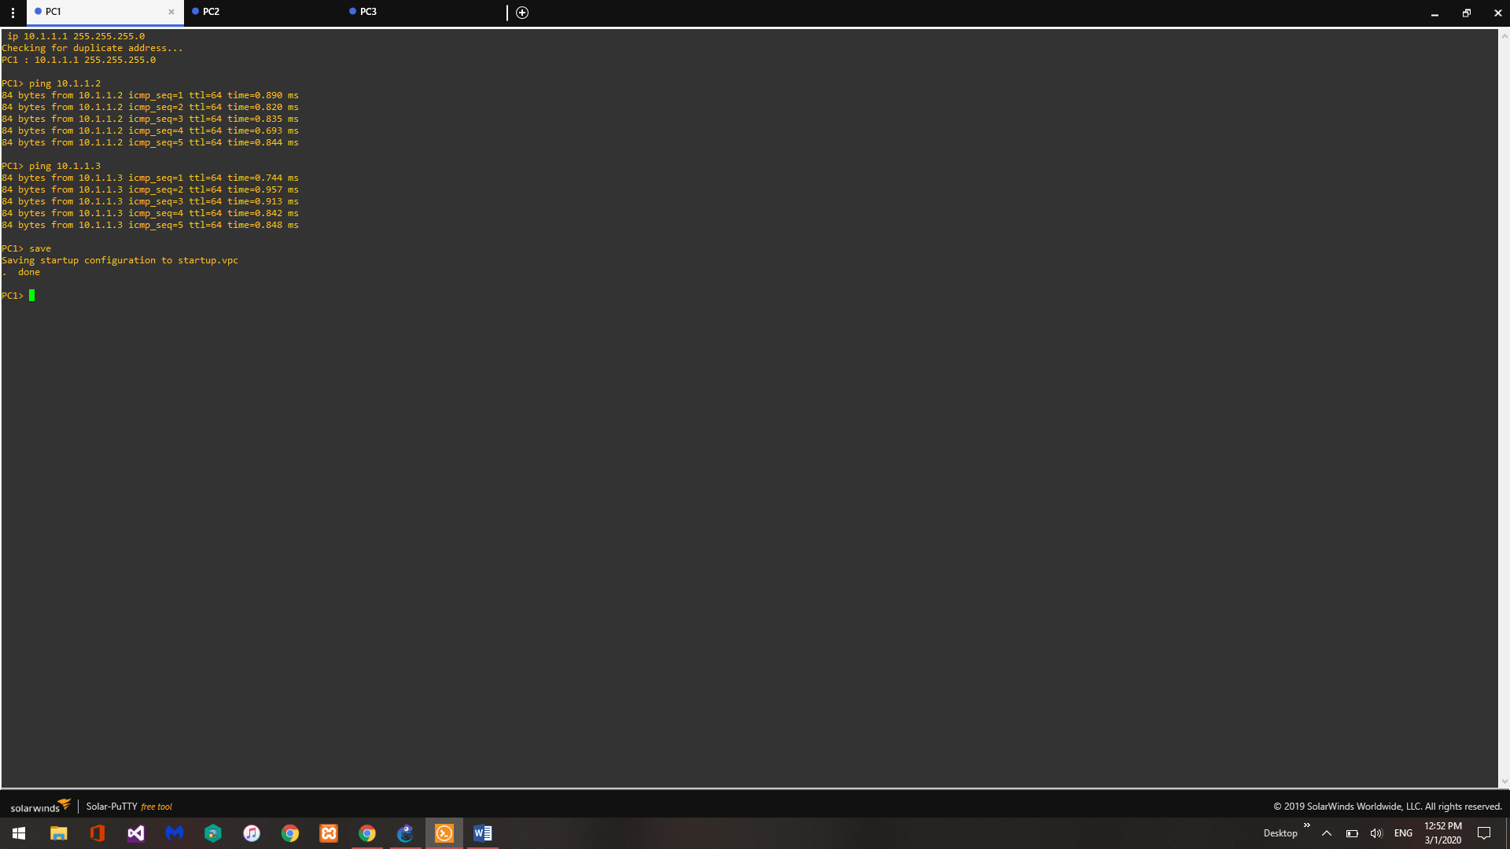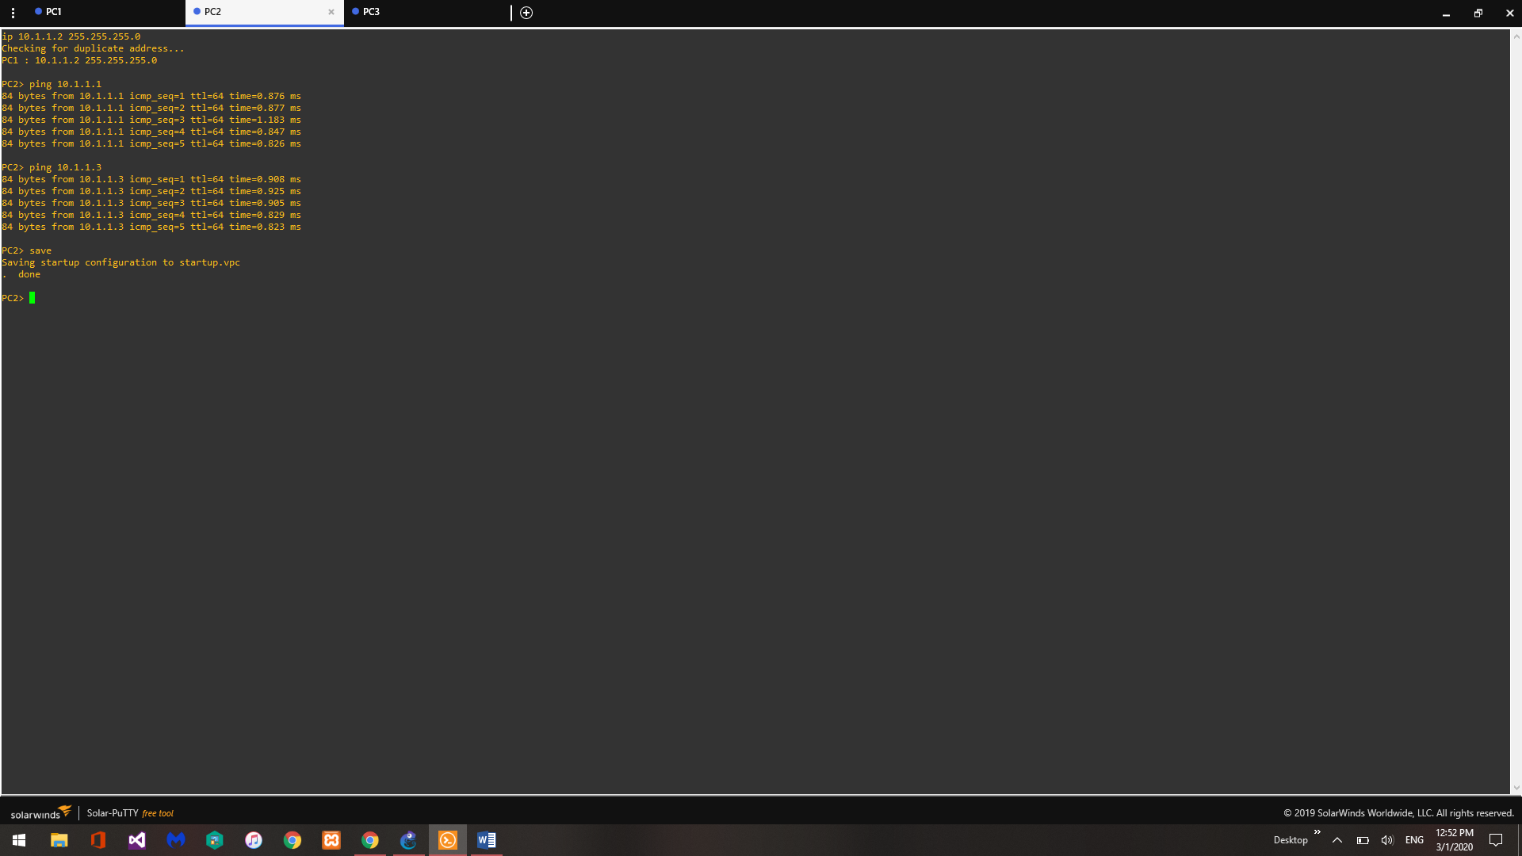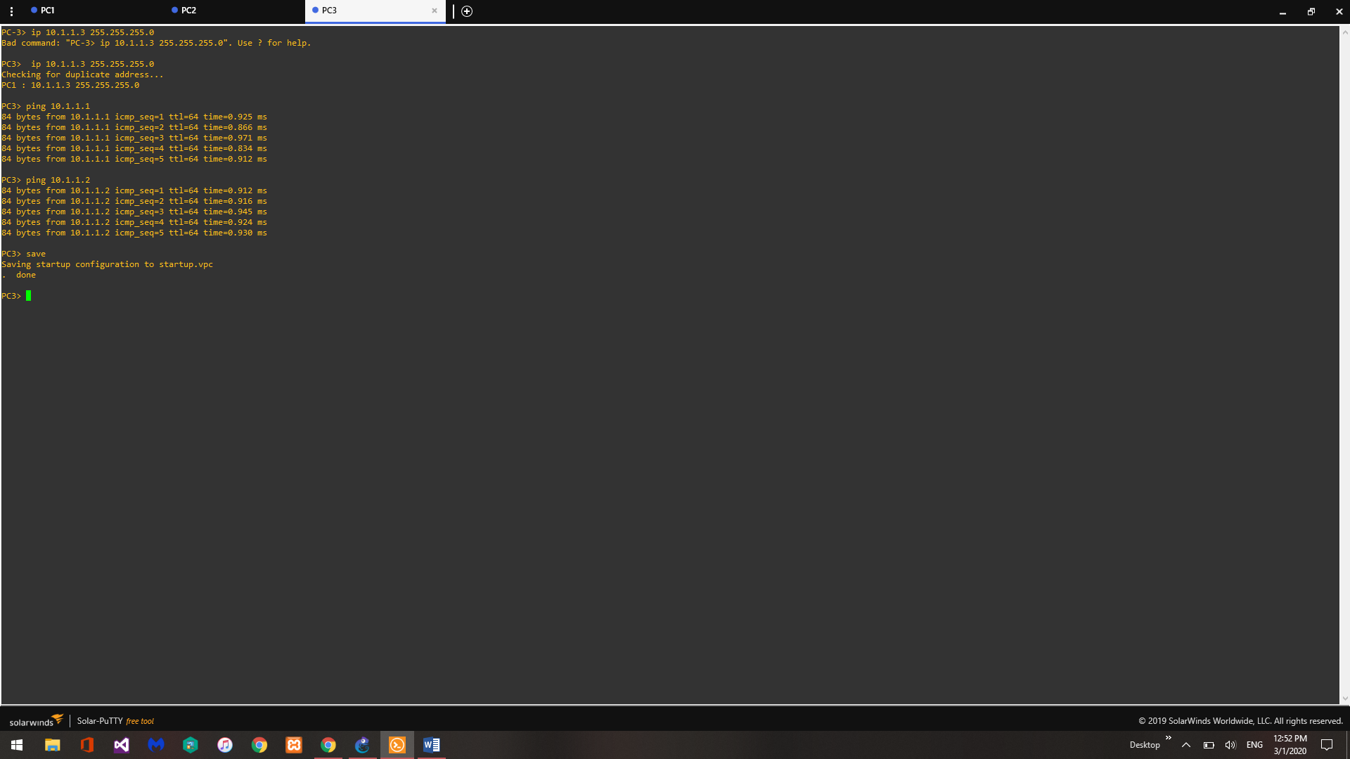

1. Are the delays identical? if yes how? if no why?

The delays are close but not entirely identical due to the differences in the network usage.

1. Are the delays symmetric? if yes how? if no why?

Once again the delays aren’t quite symmetrical but they are close, assumedly due to variations in network usage over time.